AI DOCUMENTATION

Aim – To Demonstrate the Dots and Boxes
Algorithm – To develop a Dots and boxes the AI Algorithm used
- Minimax Algorithm
The minimax algorithm is a decision-making algorithm used in two-player games to minimize the possible loss for a worst-case scenario, assuming the opponent plays optimally. It works by recursively evaluating all possible moves to choose the one that maximizes the player's minimum gain.
Minimax Algorithm
Description: The Minimax algorithm is typically used in game theory for decision-making in two-player games. It minimizes the possible maximum loss for a player assuming the opponent plays optimally. The algorithm evaluates all possible moves and their outcomes to choose the move that maximizes the player's minimum gain.
In Context: In the Dots and Boxes game with AI, two players take turns drawing lines between adjacent dots on a grid, aiming to complete boxes and score points. The game state is managed using arrays that track horizontal and vertical lines as well as completed boxes. The AI components include a SimpleAI, which makes random moves, and a more sophisticated MinimaxAI that utilizes the Minimax algorithm with Alpha-Beta pruning to strategically evaluate and select the best moves based on future game outcomes. The graphical interface, built with Pygame, visually represents the game board, showing dots, lines, and completed boxes, while dynamically updating the display to reflect each AI's actions and the overall game progression.

Code –
from tkinter import *
import numpy as np
class Dots_and_Boxes():
def __init__(self):
self.window = Tk()
self.window.title('Dots_and_Boxes')
self.canvas = Canvas(self.window, width=size_of_board, height=size_of_board)
self.canvas.pack()
self.window.bind('<Button-1>', self.click)
self.player1_starts = True
self.refresh_board()
self.play_again()

def play_again(self):
self.refresh_board()
self.board_status = np.zeros(shape=(number_of_dots - 1, number_of_dots - 1))
self.row_status = np.zeros(shape=(number_of_dots, number_of_dots - 1))
self.col_status = np.zeros(shape=(number_of_dots - 1, number_of_dots))

self.player1_starts = not self.player1_starts
self.player1_turn = not self.player1_starts
self.reset_board = False
self.turntext_handle = []

self.already_marked_boxes = []
self.display_turn_text()

if not self.player1_turn:
self.ai_move()

def ai_move(self):
for r in range(number_of_dots - 1):
for c in range(number_of_dots):
if self.row_status[c][r] == 0
self.update_board('row', [r, c])
self.make_edge('row', [r, c])
self.mark_box()
self.refresh_board()
self.player1_turn = True
self.display_turn_text()
return

for r in range(number_of_dots):
for c in range(number_of_dots - 1):
if self.col_status[r][c] == 0:
self.update_board('col', [r, c])
self.make_edge('col', [r, c])
self.mark_box()
self.refresh_board()
self.player1_turn = True
self.display_turn_text()
return

def click(self, event):
if not self.reset_board:
if self.player1_turn:
grid_position = [event.x, event.y]
logical_positon, valid_input = self.convert_grid_to_logical_position(grid_position)
if valid_input and not self.is_grid_occupied(logical_positon, valid_input):
self.update_board(valid_input, logical_positon)
self.make_edge(valid_input, logical_positon)
self.mark_box()
self.refresh_board()
self.player1_turn = not self.player1_turn

if self.is_gameover():
self.display_gameover()
else:
self.display_turn_text()

if not self.player1_turn:
self.window.after(500, self.ai_move
else:
self.canvas.delete("all")
self.play_again()
self.reset_board = False

game_instance = Dots_and_Boxes()
game_instance.mainloop()

Output –
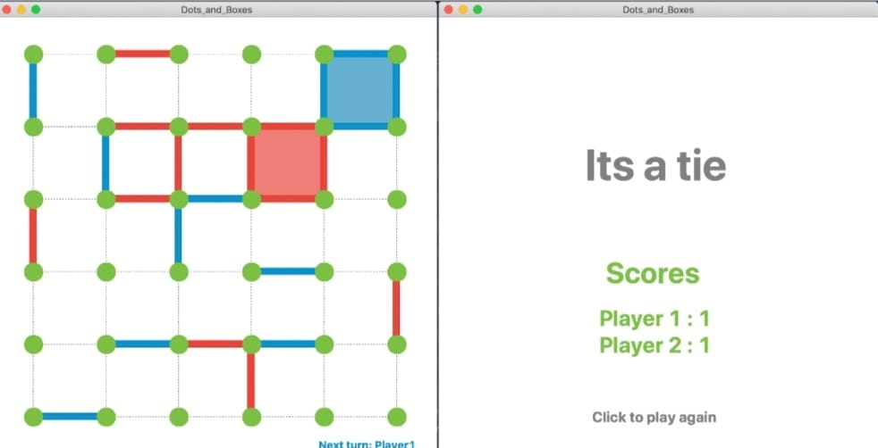

Conclusion – The Dots and Boxes game has been demonstrated Successfully.

